LEGO Piece Finder Delivery Report
Project Overview
The LEGO Piece Finder is an AI-based image recognition tool designed to help users identify LEGO pieces using visual input. The project focuses on applying computer vision techniques to classify LEGO parts accurately, supporting users who want to complete sets or find inspiration from loose LEGO collections. The solution emphasizes technical robustness, usability, and responsible AI development.
Project Goals
- Train an AI model capable of recognizing LEGO pieces from images
- Optimize datasets to balance performance and efficiency
- Evaluate model performance using clear metrics and visualizations
- Test usability and reliability through structured testing
- Design and validate a realistic end-product prototype
Technical Implementation
Data Preparation
Datasets were sourced from Kaggle and evaluated for quality, diversity, and relevance. The data was optimized by reducing dataset size while maintaining sufficient variation across LEGO pieces, resulting in faster training times without significantly impacting accuracy.
Virtual environments were managed independently to ensure compatibility between datasets, dependencies, and hardware acceleration.
Model Training & Machine Teaching
YOLO models were trained using multiple configurations, experimenting with batch sizes, image resolutions, and epochs. The model was adapted from standard classification tasks to support single-image recognition, aligning with the intended user interaction.
Training and inference were executed in self-created PyTorch environments, demonstrating independent setup and maintenance of machine learning pipelines.
Evaluation & Data Visualisation
Model performance was evaluated using confusion matrices and visual feedback. Multiple iterations of confusion matrices were created to analyze misclassification patterns and guide improvements. These visualizations helped communicate model performance clearly.
Prototype & User Experience
A prototype of the final end product was designed and tested in Figma to explore user interaction, flow, and overall usability of the LEGO Piece Finder. This interactive prototype allowed users to experience the full workflow, from scanning LEGO bricks to viewing AI-based predictions and related LEGO sets. By testing the prototype with LEGO enthusiasts from different age groups and experience levels, I was able to evaluate whether AI predictions could be presented in a clear, understandable, and motivating way.
User feedback was collected through a structured Google Form after testing the prototype, focusing on clarity, ease of identifying bricks, understanding of brick-to-set relationships, enjoyment through gamification, and overall usefulness. Observing users interact with the design and analyzing their feedback helped validate design choices and revealed areas for improvement in navigation and information hierarchy. This process confirmed that the concept reduces frustration, improves usability, and adds societal value by making LEGO organization and set reconstruction more accessible and engaging, while also validating the design direction before full technical development.
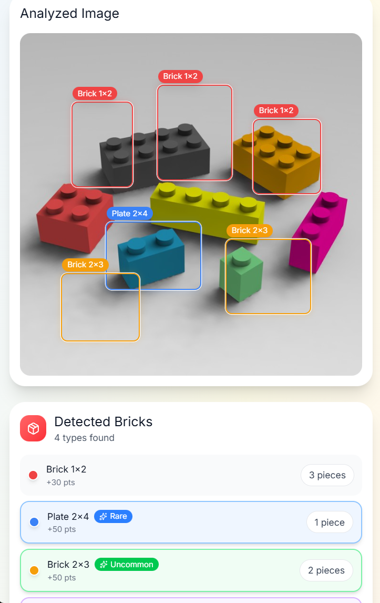
Testing & Validation
The LEGO Piece Finder was tested using real images and evaluated through four defined KPIs: classification accuracy, metadata retrieval, robustness, and responsiveness. Testing included labeled datasets, confusion matrices, precision metrics, and real-world variations in lighting, angles, and occlusions. Results were documented in a structured test report and showed strong performance, with macro precision improving from 0.54 to 0.95 and metadata correctly returned for 97% of identified parts. While the system meets all performance targets and is suitable for practical use, predictions are not yet fully reliable in cases of heavy occlusion, leaving room for further optimization.
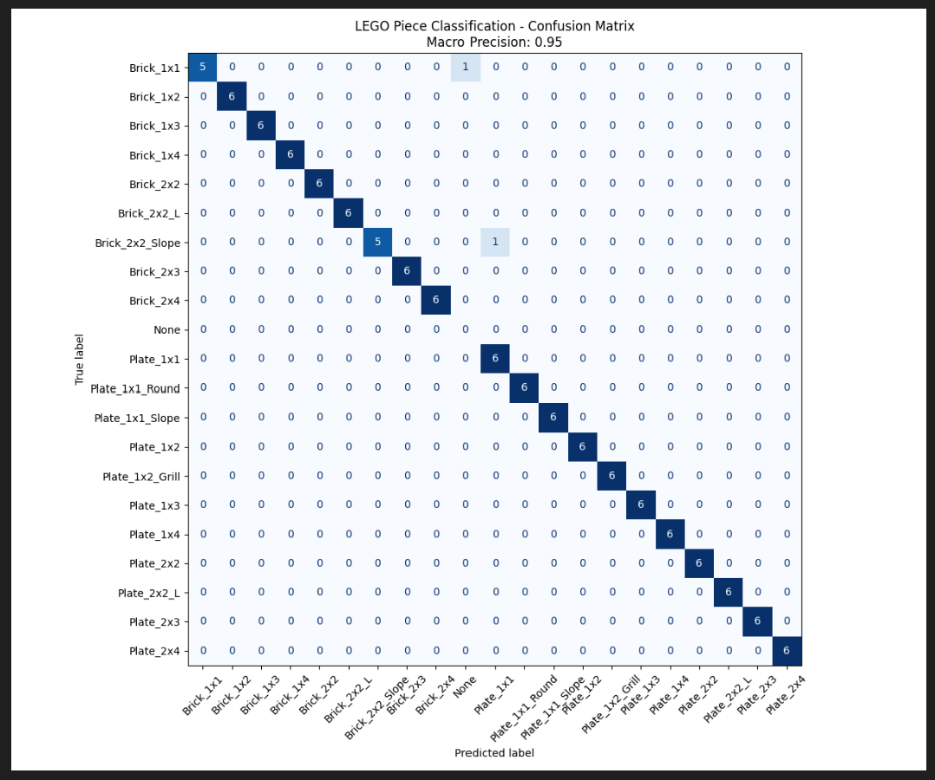
Societal Impact & Ethics
To incorporate a societal impact assessment that considers responsible AI usage within the LEGO Piece Finder application, a corresponding analysis has been performed. Also, as seen within the feedback of the consultants, it is necessary to properly identify and define the user community. An accompanying study of existing literature reveals that there exists a community of task-driven enthusiasts of LEGO, such as enthusiasts of MOCs and LEGO set collectors. This community is concerned with efficiency and completion and is irritated when searching for known components.
Through the intentional targeting of these people, the project guarantees the value addition accruable to automation, as it decreases the time spent searching and thinking. Conversely, builders who are essentially searchers and have passion for the process of search, as they get value from it, should not be impacted negatively through the builders not being the target group of the project, as they are not the intended beneficiaries.
Limitations & Future Development
Several improvements are required to further mature the LEGO Piece Finder:
- The system still needs to be connected to a dataset containing complete LEGO sets, enabling comparison between detected pieces and known sets.
- Future versions should support scanning multiple LEGO bricks within a single image, allowing users to analyze entire piles of pieces at once.
- A new dataset, or an extension of the existing dataset, should be created to support multi-brick recognition and more complex real-world scenarios.
- Research into alternative image recognition models beyond YOLO is recommended to improve accuracy, as current predictions are not yet fully reliable.
These improvements would significantly enhance both accuracy and real-world applicability.
Reporting & Documentation
All project phases were thoroughly documented, including project proposals, domain understanding, dataset optimization, model training, evaluation, testing, risk assessments, societal impact analysis, and future plans. Structured documentation and consistent linking of evidence ensured clarity and methodological soundness.
Conclusion
The LEGO Piece Finder delivers a functional AI-based image recognition solution supported by a validated Figma prototype. Through independent technical work, structured testing, and responsible design considerations, the project demonstrates proficiency across data preparation, machine teaching, evaluation, reporting, and ethical reflection. While the current model is not yet 100% accurate, the project provides a strong foundation for future technical expansion and refinement.

